Contact Information

Today’s Date:

Full names:

Address:

Phone:

Email:

Personal information

Dates of birth:

Emergency contact number:

History

Family members:

Medical issues:

Trauma:

Addictions:

Medications:

Previous therapy/coaching?

Other:

Primary Reason(s) for you visit?

Wheel of Life
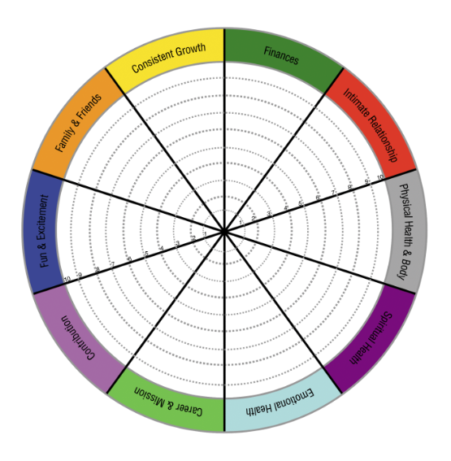

Values

Authenticity  Achievement  Adventure  Authority  Autonomy  Balance  Beauty  Boldness  Compassion  Challenge  Citizenship  Community  Competency  Contribution  Creativity  Curiosity  Determination  Fairness  Faith  Fame  Friendships  Fun  Growth  Happiness | Honesty  Humor  Influence  Inner Harmony  Justice  Kindness  Knowledge  Leadership  Learning  Love  Loyalty  Meaningful Work  Openness  Optimism  Peace  Pleasure  Poise  Popularity  Recognition  Religion | Reputation  Respect  Responsibility  Security  Self-Respect  Service  Spirituality  Stability  Success  Status  Trustworthiness  Wealth  Wisdom

- Circle the top 5 values in your life that resonate with you.

- Rank your values 1-5: How well is the value reflected in your life now?
1._____________________ Needs work Somewhat Lived Fully
2. _____________________ Needs work Somewhat Lived Fully
3. _____________________ Needs work Somewhat Lived Fully
4. _____________________ Needs work Somewhat Lived Fully
5._____________________ Needs work Somewhat Lived Fully
Primary Focus

Please identify one area of interest that you want to focus on with me as your coach.

Example:

Get a promotion

“I would like to develop positive work-related skills that show my employer that I'm valuable and worth promoting. I would like to accomplish this over the next three months.”

Goals and Commitments

A goal is a specific activity or process you want to complete which is measurable i.e. “I will lose 10 pounds in 2 months” “I want to earn $10,000 more this year”. A commitment is a quality of life shift i.e. “I am committed to eating better and getting fit” “I am committed to earning more money this year”.

Commitment Goals

Health | 1 | I want to lose more weight | Lose 10 pd in 2 months
 | 2
Money | 1
 | 2
Friends and Family | 1
 | 2
Relationship | 1
 | 2
Personal Growth | 1
 | 2
Fun and Recreation | 1
 | 2
Physical Environment | 1
 | 2
Career | 1
 | 2

Daily Habits

Habits are positive actions you can take each day to achieve your goals. Based on the results of your Wheel of Life Exercise, what actions would help you move forward? I.e. spending 20 minutes a day exercising, talking with your kids without your cell phone etc.

- _____________________________________________________________________
- _____________________________________________________________________
- _____________________________________________________________________
- _____________________________________________________________________

Completion Log

Item to Complete Do By Done

Remove junk from pantry | Wed | Check

