CRAFT-RECOVERY COACHING Handout 1a

Group Trust & Rapport Guidelines
The Community Reinforcement and Family Training group is designed to help people who are coping with a family member/friend who has a substance abuse problem to better understand their role in their loved one’s life. The group will provide participants with information and support that is useful for making changes in the present and for planning the future. The group will keep information confidential except as required by law. State law may require reporting to a state agency if a person is a danger to himself or herself, a danger to others, or engaged in certain types of abusive behavior, e.g. abuse of a child or elder. The group leaders will use the following guidelines to further the goals of the group. Group leaders will ask participants to:
1. Be on time for all sessions and understand how to use Zoom effectively.
2. Come on time and come regularly.
3. Show respect to others by listening carefully and talking one at a time. No one will be put on the spot to share issues that they want to keep private.
4. Give and receive feedback in a direct, respectful, and constructive way.
5. Allow time for all group members to participate.
6. Stay in the group and talk through an issue even if you are upset or angry about something that someone has said. If feeling overwhelmed, please ask the group leader and participants to give you a few minutes to clear your head or cool off before continuing with the issue.
7. Protect others’ privacy by keeping all information shared in the group confidential.
8. Set aside bias, judgement, cynicism.
Please sign the following statement of understanding:
I understand that it is essential that members of the Recovery Coach CRAFT-groups have the right to privacy. Therefore, I understand that it is expected that all group participants will not discuss information shared in the groups with anyone outside of the groups.
____________________________________ _____________________
Participant Signature Date
____________________________________ _____________________
Coach Signature Date
If unable to attend the session, please call Daniel at:

CRAFT-RECOVERY COACHING Handout 1b
Problems Due To Alcohol and/or Drugs
Alcohol and drugs can impact family and friends in many ways. Look at the list below and identify areas in your life that have been affected by substance abuse. Rate how severe the problem is for you and how severe you think the problem is for the person in your life who has been misusing alcohol and/or drugs.
Key for rating the severity of problem for yourself and your loved one:
1 = No Problem 2 = Mild 3 = Moderate 4 = Serious 5 = Severe Problem
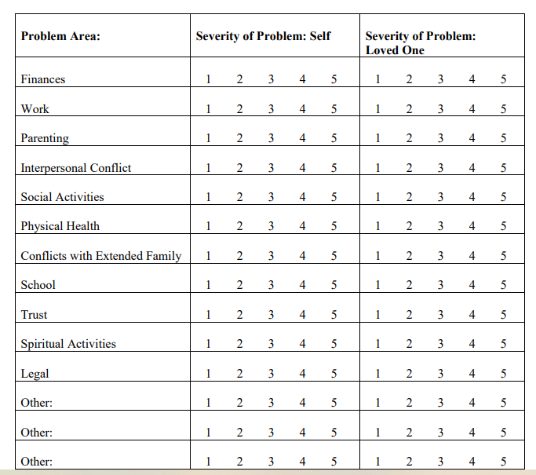
Which of the above issues is the biggest problem for you now?
Please write your thoughts on the back of this handout about how these issues may prompt misuse.
Discussion: How do you manage these difficult situations?
CRAFT-RECOVERY COACHING Handout 1c
Recognizing Triggers and Signs of Intoxication
As a Concerned Significant Other, you have observed your loved one before and during a drinking or drug use episode.
What are your loved one’s triggers and signs of substance use?

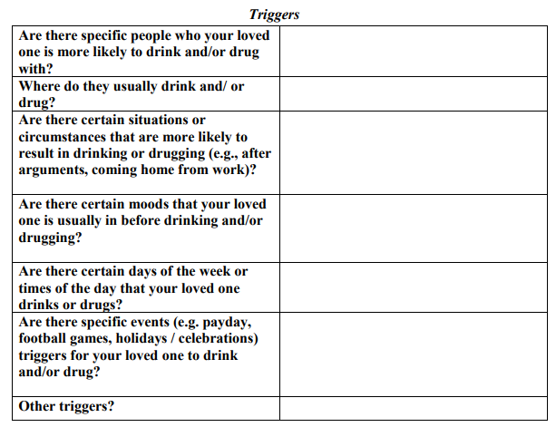

CRAFT-RECOVERY COACHING Handout 1c Page 2
Recognizing Triggers and Signs of Intoxication
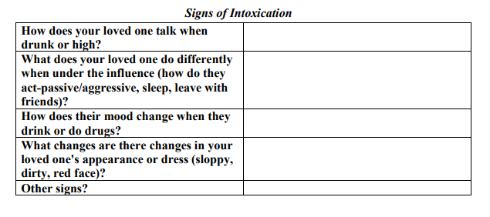

CRAFT-RECOVERY COACHING Handout 1d
Research On CRAFT Model Success in Working with Loved Ones
Family members using the CRAFT model have the most success in having loved ones seek treatment — 64% of them were able to get their loved one to enter treatment. Family members trained in the other two methods -Johnson Institute intervention approach (the most commonly used in the US), and others followed Al-Anon’s facilitation therapy, were less successful – 30% for the Johnson Institute and just 13% for Al-Anon. Family members experienced improvement on problems like anger, depression and anxiety, no matter which training they participated in.
Relationships between family members and their loved one also improved. Researchers soon set to work to determine whether CRAFT would be equally successful with drug-using loved ones. Three studies were conducted, and the results were encouraging. One study showed that CRAFT was successful with loved ones who were using mainly marijuana, cocaine, and opiates. Out of 62 CRAFT-trained family members, 74% loved ones entered treatment.
How did CRAFT perform for drug-using loved ones, compared to other approaches?
A 1999 study sent half of the participating family members to CRAFT training, and the other half to Al-Anon/Nar-Anon meetings. In the case of family members trained in CRAFT, 64% were able to help their loved ones enter treatment, whereas only 17% of the Al-Anon family members succeeded. Next, researchers were interested in seeing whether outcomes would be improved by adding additional sessions (aftercare programs). In one study, 90 family members were randomly assigned to CRAFT, CRAFT plus an aftercare program , or Al-Anon/Nar-Anon. Engagement rates for both CRAFT (59% engaged in treatment) and CRAFT plus an aftercare program (77% engaged in treatment) were significantly higher than those of the Al-Anon/Nar-Anon condition (29% engaged in treatment). The CRAFT plus an aftercare program families had only slightly higher success levels than the families using CRAFT without aftercare. We believe this is because families taught CRAFT over 12 weeks get the core principles, they need to manage the situation…more training is not necessary. A 2007 study wanted to determine whether CRAFT is effective on parents of adolescents. Forty-two parents received CRAFT training. They learned to facilitate their adolescents’ entry into treatment, to support their adolescents’ behavior changes following treatment, and to improve parent and family functioning. The parents experienced a significant reduction in negative symptoms, and 71% successfully engaged their resistant youths into treatment. A 2014 randomized clinical control trial looked at adding CRAFT while a loved one is in treatment. Like in other CRAFT studies, those that did best were parents of young adults. CRAFT increased retention and lowered drug use. In summary, these studies demonstrate that CRAFT is an effective method for family members to influence their loved ones, especially loved ones who are resistant to treatment, to seek treatment. The research shows that loved ones’ engagement rates for CRAFT are significantly higher than with other approaches. An additional benefit is that family members experience major psychological relief from using the skills of CRAFT. It is especially impressive that CRAFT is applicable to all different ethnic groups, substances, and family member-loved one relationships - Sisson and Azrin (1986)

CRAFT-RECOVERY COACHING Handout 2a
Past Reactions to Drinking / Drug Use
In the past, you have probably reacted to your loved one’s drinking or drug use in a number of different ways. This worksheet will help you identify these different ways of responding. Then, we will look at how your loved one responds to your efforts.
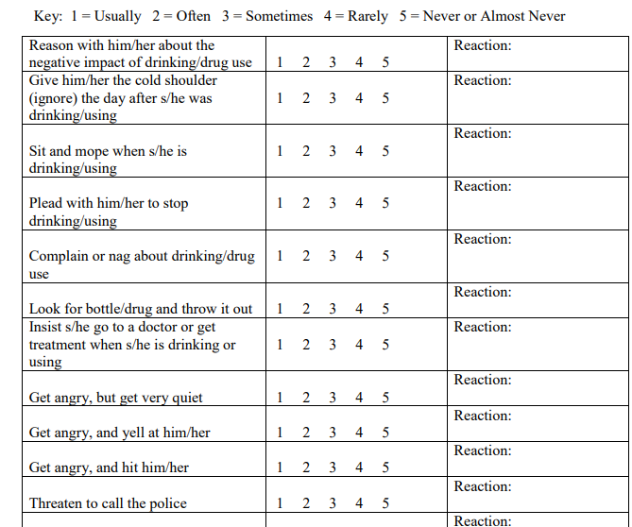

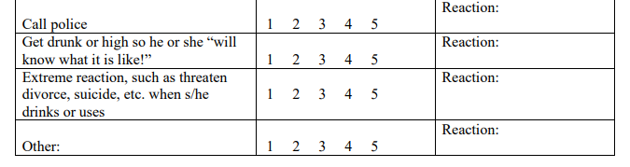

CRAFT-RECOVERY COACHING Handout 2b
Coping With Intoxication: When Your Loved One Is Drinking / Using

It is helpful to take the focus off your loved one when he or she is drinking or using and focus on other activities. Say something like, “I am going to do other things because I don’t enjoy time with you when you are drinking / using.”
Do:
• Go about your daily schedule
• Find something to do to get your mind off your loved one’s drinking / using
• Get involved in a favorite hobby or activity
• Take a walk to cool off or relax
• Get out of the house if you are getting tense or frustrated
• Take the kids out to a playground or park, or to a friend’s or family member’s house
• Go to the library, read a book
• Treat yourself to a leisurely bath
• Use relaxation techniques, prayer, or meditation to stay at ease
• Read an inspirational book, e.g. the Bible, poetry, recovery devotionals, etc.
• Attend an Al-Anon meeting
• Talk to a friend or family member about what is bothering you
• Do ____________________________________________________________
• Do ____________________________________________________________
• Do ____________________________________________________________
• Do ____________________________________________________________
Do ____________________________________________________________
• Do ____________________________________________________________
• Do ____________________________________________________________
• Do ____________________________________________________________

CRAFT-RECOVERY COACHING Handout 2b- Page 2
Coping With Intoxication: When Your Loved One Is Drinking / Using

Withdraw attention from your loved one when he or she is drinking or using.
Do not:
• Try to punish him/her
• Lecture or give rational explanations why drinking or using is “bad”
• Nag the drinker/user to stop
• Pour alcohol/drugs down the drain
• Follow him/her around to make sure he/she stays out of trouble
• “Cover up” for his/her drinking/using behavior
• Try to talk to him/her about important decisions, like the future of your relationship
• Talk about the situation in a way or place that the drinker/user can overhear, e.g. calling your mom and saying loudly, “He’s at it again. Can you hear him banging around the house?” or announcing to the kids, “Your mother is drunk again!”
• Threaten the drinker/user
• Resort to emotional pleading, crying
• Get caught up in yelling and fighting about the drinking
• Get drunk or high to show the drinker/user "what it's like”
• Act "crazy" so the drinker can see what it is doing to you
• Try to engage him/her in a fun activity to decrease the tension
• Do not ________________________________________________________
• Do not ________________________________________________________
• Do not ________________________________________________________
• Do not ________________________________________________________

CRAFT-RECOVERY COACHING Handout 2c
Rewarding Sobriety: When Your Loved One Is Not Drinking or Using

There are four basic rules for giving positive attention-
a) Be clear on why you are giving positive attention- to allow your loved one to see life is more rewarding when they are sober.
b) Give positive reinforcers only when the drinker is sober and not hung-over.
c) Pick an optimal time to use positive attention (i.e. the drinker is sober and in a good mood, and you want to do this and are in an upbeat and positive mood).
d) Have a good time with the person you love, focusing on enjoying their positive actions.
Do:
• Spend time with him/her doing something fun when he/she is not drinking
• Take a walk together
• Talk about topics he/she enjoys
• Prepare your loved one’s favorite foods
• Give a 5-minute shoulder rub
• Go out to a restaurant that does not serve alcohol
• Watch a movie together
• Play a card or board game together
• Read a book together
• Give praise and support
• Give small or inexpensive gifts
• Take a bath together
• Do a chore around the house that he/she does not like to do
• Get involved in an activity that your loved one enjoys
• Offer his/her favorite sexual activity

CRAFT-RECOVERY COACHING Handout c Page 2
Rewarding Sobriety: When Your Loved One Is Not Drinking or Using
Write your own personal positive attention activities:
• Do ____________________________________________________________
• Do ____________________________________________________________
• Do ____________________________________________________________
• Do ____________________________________________________________
• Do ____________________________________________________________
• Do ____________________________________________________________
• Do ____________________________________________________________
• Do ____________________________________________________________
• Do ____________________________________________________________

It is helpful to give positive attention to your loved one and it is important to be sensitive to triggers that can promote the reasons for misuse, avoid “power plays” or I know better than you dynamics, steer clear of asking “why?”

CRAFT-RECOVERY COACHING Handout 2d
Negative Consequences / Anticipating Negative Repercussions

Negative consequences that you could allow if your loved one drinks/drugs:

Likely reactions from your loved one are:

Your response to these reactions: (Planning may help you clarify exactly what you would like to have happen, while at the same time being prepared for "the worst.")

CRAFT-RECOVERY COACHING Handout 2e
A Typical Family “Discussion”
Often, we are just talking to our loved one- then BOOM! We begin arguing with our loved one before we know it. Sometimes we are angry and really want to let them know how we feel, and other times the argument just seems to sneak up on us. If you are here in this training, there is some part of you that wants this to stop. The first step is to become more aware and understand what happens with these “discussions.” Here is the background of this discussion:
A husband and wife are cleaning up after dinner. The wife says that it is late, and she is going to bed after turning on the dishwasher. The husband says that they do not have any “alone time” anymore, after the kids go to bed, she immediately retires. The wife explains to the husband that she worked all day, cooked dinner, fed the kids, bathed them, put them to bed, then fixed his meal and then ate with him after he returned home from work at 9pm. She says she is beat.
A typical family discussion might proceed like this:
Him: I have told you so many times not to nag at me about work, I have to work late!
Her: Well, I would not nag you if you did not come home smelling of booze.
Him: What do you really mean? You think I went to a bar?
Her: No, I have had to put up with your drinking for so long I know you drink out of a bottle in your desk
Him: And I have had to put up with your nagging since we first met!
Her: I hate it when you are drunk!
Him: Why do you always assume that I am drunk? So I take a swig of whisky, so what?
Her: I can never trust you to drink just one swig. No it is always half a pint or more! Do you remember that time that you passed out and there were three empty pints in your desk drawer?
Him: Do you always have to live in the past?
Her: It is to show you all the times I have been hurt by your drinking....You should know by now how much it bothers me.
Him: All I know is that you are nagging me, and it just makes me want to drink even more!
Her: I see, it is my fault you drink, it is your boss’s fault you drink, it is a bright sunny day, so you drink! It is just an excuse!
Him: Well if it bothers you so much- go home to Momma. You do not have to live with me
Her: “Look, you are the drunk, not me. This is your problem...you have to live with you!
CRAFT-RECOVERY COACHING Handout 2f
Positive Communication
Dealing with someone with whom you are in conflict is difficult. If that person is misusing a substance, it is even more complicated. Below are the steps you need to use in order to improve your communication with those people that you care about. We are going to read this information and then use along with a role-playing exercise.
Person #1 is the misuser
Person #2- will go through each one of these effective communication skills in responding and communicating to person #1 (the misuser)
Remember- pretend that you are sitting down to discuss with a loved one and use these steps.

Steps for Effective Communication
1. Calm down / Find the right time. Take a time out or use a distraction if you are overwhelmed with emotions. Give yourself some time to organize your thoughts and to calm your emotions enough that you are not speaking just from anger. If you are that upset, you will just blow up and say things that you either did not mean to say or things that are not helpful. Do not just walk away without telling the other person that you need some time, otherwise they will not understand and will get even angrier. Tell them that you need some time and also tell them what time you would like to have the discussion.

2. Be brief. No one wants to hear a lecture. When we keep it brief, the other person stays in the conversation. The person feels that you are talking with them, not talking down to or against them. One of the main ways to keep it brief is to not drag in past fights or issues that do not relate to the present subject. When you drag in old fights, your current issue will be lost among the river of emotions and memories. In addition, the other person will not listen to anything you have to say about what is bothering you now because he/she is too wrapped up in being defensive about the past.

3. Be specific. Figure out what exactly it is that you want to say before you say anything. Avoid generalizations, such as “You always get drunk on weekends” or “I can never trust you.” Focus on just the facts without making assumptions, jumping to conclusions, or making inferences. This means saying “you did not come to dinner last night” instead of saying “you did not come to dinner because you don’t love me anymore and you were out drinking.”

CRAFT-RECOVERY COACHING Handout 2f Page 2

4. Develop empathy. Take the time to understand the other person’s point of view; take a walk in their shoes. Understanding and then expressing this understanding to the other person can help you when you try to communicate because you understand him/her better. It also shows them that you care enough about them to try to understand their point of view even though you may disagree. When you show that you are trying to understand something about another person, they are more likely to accept that you have something important to share with them.

5. Accept partial responsibility. “It takes two to tango” is a polite way of saying that both parties in a conflict are likely to be less than perfect. Understanding and acknowledging your part in the problem goes a long way in breaking out of the pattern of conflict.

6. Be positive. Always begin a serious conversation with something positive. This not only helps the listener but helps you remember that you do appreciate something about the other person. Think of something that you really like about them or just tell them you love them. Another way to put it is: “say what you want, not what you don’t want.” Instead of saying, “I hate it when you drink” say “I like it when you are sober.”

7. I feel. Always acknowledge that your feelings are your own. Do not blame the other person for how you feel, (“You make me so mad; you always make me sad”). This will always put them on the defensive -- every time. Your feelings are your own. Nobody makes us feel any way; we allow our emotions to come out. The following phrase is the best example of how to communicate your feelings. The “I” statement is one of the best communication tools that we have.
When you drink, I feel ________ (sad, mad, worried, scared...)

8. I want. It is now time to state what you want, and to share what you would like from your loved one. Try to make your request reasonable and something your partner can actually do.
“I would like it if you / we could ______________ (“could call me before you are late for dinner, could spend time together going to the movies or out to eat.”).

CRAFT-RECOVERY COACHING Handout 2f Page 3

9. Be positive. Always end with something positive. You can end the communication positively by sharing with your loved one:
a. What they may get if they follow through with what you request – and how your relationship / their life may be improved.
b. Say something positive about him/her again (e.g., you like their commitment to the relationship, admire their struggle to make it through the tough times).
c. Offers to help him/her accomplish the task to help move things in a positive direction.

Effective - Examples of positive statements:
“If you remember to call me when you’re going to be late, then we will have more trust in the relationship and we will get along better.”

“If we spend more sober time together, we will grow closer together and we can show how much we love each other – instead of always yelling.”

“I love you; you are so extremely smart; I want to see you do what you want to do-I want to see you be happy rather than fighting with you all the time.”

Try to write your own positive ending statement. Remember Be Positive

I feel…
I want…
Putting it all together
I like it when you are sober.
When you drink, I feel ________
I would like it if you / we could ______________
If ____________ then ______________________

CRAFT-RECOVERY COACHING Handout 2g
Positive Communication- Practice Role-Plays

PRACTICE ROLE-PLAYS
Person #1 is the misuser- they improvise by using one of the four scenarios below
Person #2- is the concerned significant other. The CSO will go through each one of the 9 effective communication responses to communicate to person #1 (the misuser). Remember- pretend that you are sitting down to discuss with your loved one and use these steps one by one in responding to each statement the misuser gives us. .

Scenario 1. Your loved one told you he would see you at 5:00 and he shows up three hours late. He has red eyes, slurred speech, and is laughing.

Scenario 2. You are balancing the checkbook and you notice that $100 has been taken out and was not recorded in the book. You notice that this was the same day your partner called to say the car broke down and that she was staying at her brother’s house. You start to ask yourself if she spent the $100 on alcohol that night.

Scenario 3. Yesterday your partner went out and used. However, he got home about 9:00pm and quickly fell asleep. The next morning, instead of getting up and using again, he eats breakfast and goes outside to work on the yard.

Scenario 4. Your loved one calls you from the road saying she had a really horrible day, and the car just broke down. When she finally gets home, she is tired, dirty, and somewhat irritable, but she is obviously sober.

CRAFT-RECOVERY COACHING Handout 2h
Developing a Support System

A support system is all of the people who help you along the way. That might include family, friends, co-workers, neighbors, church or club members, people interested in the same recreational activities or sports, etc. All of you can benefit from learning ways to establish new and re-establish old relationships. How does a person go about developing a support system?

Revive old friendships. Break out of a rut, pick up the phone, and call that person that you have not gotten around to calling for a while. It might be an old friend or a relative that you have not talked to in a while. Invite that friend over for coffee or to lunch at a restaurant. Think of 4 people you could contact that you have not seen in a while.

1.__________________________________
2.__________________________________
3.__________________________________
4.__________________________________

Practice "small talk." Start conversations with others and break the ice. It is possible that your neighbor or acquaintance would also like someone to talk to. Develop conversation skills. If you are not “good” at talking to others, remember a few simple steps. First, break the ice by saying “Hello.” Second, ask the other person about himself or herself, i.e. what they have been doing, what they are interested in, etc. Third, tell a little something about what you have been doing or what you enjoy. Practice with a partner.
Develop interests that can be shared with others. Find a hobby that you enjoy and where other people who like that hobby get together. Ask around, call your town’s recreation department, and look in the paper or the internet. What are three things that you like to do with other people? (Examples are bowling, walking, quilting, etc.)

1. _______________________
2. _______________________
3. _______________________
CRAFT-RECOVERY COACHING Handout 2h Page 2
Developing a Support System

Find someone you can really talk to and confide in. A close friend or family member will help you to find out if others see the problem in a similar way. You will be able to get the help of your friend in finding more things you enjoy (reinforces). You will also have a practice partner to practice exercises and role-plays at home. The friend may have ideas that you have missed. These may include suggestions for non-drinking alternatives (for competing activities to drinking and/or using) or a "safe house" in the case of abuse. We have asked you to ignore your loved one when they are drunk, high, or hung-over. You may need to vent your feelings with someone, and you could “blow off some steam” with a confidante. Think of a few people who are or could be someone you could really talk to.

1. _______________________
2. _______________________
3. _______________________

CRAFT-RECOVERY COACHING Handout 2i
Barriers to Rewarding Yourself

It may be easy or difficult for you to reward yourself for hard work, but it is extremely helpful when you find ways to reward yourself in big and small ways. Keep in mind that although there are barriers to rewarding yourself, they can be overcome. Use the scales below to rate each item as to the likelihood of it being a barrier (obstacle) to rewarding yourself.
1 = Very Likely 2 = Likely 3 = Maybe 4 = Unlikely 5 = Very Unlikely
Barriers to rewarding myself are:
I have not rewarded myself in the past. 1 2 3 4 5
I do not have any money. 1 2 3 4 5
I do not have the time. 1 2 3 4 5
I do not know how. 1 2 3 4 5
I do not deserve to be rewarded. 1 2 3 4 5
I feel guilty if I reward myself. 1 2 3 4 5
No one has given me permission to reward myself. 1 2 3 4 5
I do not have the ability to reward myself. 1 2 3 4 5
Since I cannot get a big reward, I will not give myself any reward. 1 2 3 4 5
Other____________________________________. 1 2 3 4 5
Other____________________________________. 1 2 3 4 5
Other____________________________________. 1 2 3 4 5
Other____________________________________. 1 2 3 4 5

CRAFT-RECOVERY COACHING Handout 2j
Rewarding Yourself
I can choose to reward myself, knowing that it is not selfish to find helpful ways to take care of myself. By rewarding myself, I can sustain a positive outlook and encourage positive behavior in myself. Please rate each activity as to the likelihood that you will actually do it.

1 = Very Likely 2 = Likely 3 = Maybe 4 = Unlikely 5 = Very Unlikely
Ways that I can reward myself are:
Take a walk 1 2 3 4 5
Take a bath 1 2 3 4 5
Eat a favorite treat 1 2 3 4 5
Talk to a friend 1 2 3 4 5
Buy myself a small item “just because” 1 2 3 4 5
Read a book 1 2 3 4 5
Listen to music 1 2 3 4 5
Visit family 1 2 3 4 5
Go to synagogue 1 2 3 4 5
Other _________________________ 1 2 3 4 5
Other _________________________ 1 2 3 4 5
Other _________________________ 1 2 3 4 5
Other _________________________ 1 2 3 4 5
Other _________________________ 1 2 3 4 5
Other _________________________ 1 2 3 4 5
Other _________________________ 1 2 3 4 5
Other _________________________ 1 2 3 4 5

CRAFT-RECOVERY COACHING Handout 2k
Recognizing Intimidation and Violence

The following are ways that one person in a relationship may intimidate or control others. The most extreme way is actual violence toward the other person.
Economic Control:
▪ not letting her get a job
▪ making him ask for money
▪ giving her an allowance
▪ taking his money
▪ not letting her have access to any income
Isolation:
▪ controlling what she does, whom he sees and talks to, where she goes
Using Children:
▪ making him feel guilty about the children
▪ using the children to relay messages
▪ threatening to take the children away
Using Intimidation:
▪ making her afraid by looks, actions or gestures
▪ smashing things
▪ destroying his property
▪ abusing pets
▪ displaying weapons
Emotional Abuse:
▪ putting him down
▪ making her feel badly about herself
▪ calling him names
▪ making her think she is crazy
▪ humiliating him

CRAFT-RECOVERY COACHING Handout 2k Page 2
Emotional Abuse:
▪ making her feel guilty
Using Coercion and Threats:
▪ making and carrying out threats to hurt her
▪ threatening to leave him, to commit suicide, or to report him to welfare
▪ making her drop charges or do illegal things
Minimizing, Denying, and Blaming:
▪ making light of past abuse or saying the abuse did not happen
▪ shifting responsibility for the abuse... “You asked for it!”
Violent Behavior:
▪ slapping or flicking
▪ blocking an exit or holding down
▪ hitting, punching, or kicking
Sexual Violence:
▪ manipulating or making a person feel guilty
▪ making a person perform unwanted sexual acts
▪ sexual assault

CRAFT-RECOVERY COACHING Handout 2L
QUIZ: How Is Your Relationship?
Does your partner:
1. Embarrass you with bad names and put-downs? Yes No
2. Look at you or act in ways that scare you? Yes No
3. Control what you do, who you see or talk to, or where you go? Yes No
4. Stop you from seeing or talking to friends and family? Yes No
5. Prevent you from getting or keeping a job? Yes No
6. Take your money, make you ask for money, or refuse to give you money? Yes No
7. Make all the decisions? Yes No
8. Tell you that you are a bad parent or threaten to take away your children? Yes No
9. Act like the abuse is not a big deal, it is your fault, or deny it happened? Yes No
10. Destroy your property? Yes No
11. Intimidate you with guns, knives, or other weapons? Yes No
12. Shove you, slap you, or hit you? Yes No
13. Force you to drop criminal charges? Yes No
14. Threaten to hurt or kill your pets? Yes No
15. Threaten to commit suicide if you leave? Yes No
16. Threaten to kill you? Yes No
If you answered Yes to even one of these questions, you may be in an abusive relationship.
If you answered Yes to questions 11, 12, 14, or 16 your life may be in danger. Please get
help before your life is lost.
A big help if dealing with domestic violence is having support:
1. How many people have you told about the intimidation or violence in your house?
_______________________________________________________________
2. How many people do you feel comfortable talking to about your relationship?
_______________________________________________________________

CRAFT-RECOVERY COACHING Handout 2L Page 2

3. How many people would believe and support you?
_____________________________________________________________
4. Where could you go if you needed a safe place to stay?

CRAFT-RECOVERY COACHING Handout 2m
Developing a Safety Plan
An important part of recovery for yourself and others in your family is staying safe and stopping all forms of abuse. Although everyone wants to be treated with respect, it can take a while to break out of negative habits. If your relationship has had violence in the past, here are some tips to help change things. Of course, there is no excuse for violence of any kind – and you are not responsible for changing your partner’s violent behavior (only he/she can do that!).
If you are dealing with the violence in isolation, consider the steps below. The more often, more extreme, and the longer the violence has continued, the more likely the violence will continue without help. We strongly recommend a specialized domestic violence treatment program for those with continuous abuse in their families.
a. Recognize escalating conflicts. Identify conflicts that are leading to a high potential for violence early on, rather than to continue in a discussion that is getting more and more intense. Recognizing conflicts are getting out of hand early on is especially important if your loved one has a history of violence or if alcohol / drugs are affecting his/her judgment.
b. Get support from a friend, a family member, or a support group. Instead of trying to deal with the abuse by yourself, get some help in finding solutions.
c. Leave the situation. In some cases, this may be as easy as leaving the room. In other situations, it may require leaving home and using a “Safe House.” This can be the home of a relative, friend, or a family shelter.
d. Police intervention. No one should have to live with abuse. If abuse occurs, contact the police immediately rather than hope things get better or do not get out of hand.
e. Get legal help through a Temporary Restraining Order. The goal of legal action through a temporary restraining order is not to get revenge for abuse. Instead, legal action is simply a way to protect yourself. A Temporary Restraining Order actually may be a benefit. A restraining order may be a way to get your loved one’s attention about the impact of their behavior (and likely the effects of substance abuse).
The CRAFT facilitator will give you additional handouts on community resources for dealing with abusive situations.

CRAFT-RECOVERY COACHING Handout 2n
When to Move Out / When to Reunite: Range of Options
1. Continue As Is
You may decide that it is not worth making the changes in your relationship or that your loved one will never change. This may be the right choice for you right now. You and your loved one may not be ready to make changes. However, should you decide in the future that you are ready and do want to make changes, please review all that you have learned in this class and draw upon your social support system.
2. Take Small Steps
At this time you may decide that what you would like to do is take small steps on your way to making changes in your relationship with your loved one. One especially important thing to realize is that you have already made one significant step in coming here to be a part of the Craft- training. Let us not forget all that you may have done already. Some other small steps may include changing the way you communicate or spending more time taking care of yourself. Each small step is just one step along the road, but without those small steps, we would never get anywhere!
3. Limit Verbal Contact
There could be a time in your relationship when you decide that you want to limit verbal contact. This may include taking time outs from discussions, scheduling discussions, or limiting conversations to things that are productive. This may help to reduce the amount of arguing and harsh feelings that can hang around consistently in a household.
4. Limit Physical Contact
Limiting physical contact with your loved one means limiting the time you are around your loved one while they are drinking/drugging -- or going somewhere else so that you are not physically in the same place when they are intoxicated. Finding something else to do or some other place to be can help you both get the time apart that you may need; it may also help you in your effort to not reinforce their drinking / drugging.
5. Trial Separation
It is possible that you may decide that you need to find out what it would be like to be separated from your loved one. This could mean finding a separate place to live or agreeing not to see or talk to the other person for a set amount of time (e.g., 2 weeks, or 3 months). This will give you a chance to focus on yourself and hopefully give them a chance to see what they could lose permanently if they do not change.

CRAFT-RECOVERY COACHING Handout 2n Page 2
When to Move Out / When to Reunite: A Range of Options

6. Permanent Separation
Divorce or the ending of a relationship may seem scary right now and the last thing that you want. However, it is the right step for some people and some situations. Sometimes the ending of a relationship can be the beginning of many other wonderful things such as better wellbeing, health, and relationships with others.

CRAFT-RECOVERY COACHING Handout 2o
Reuniting Plan

I would like to reunite with you; however, in order for our relationship to go forward, I believe that there must be some changes in our situation and relationship. I will move back when:
_____ You have been sober for _____ days.
_____ You will tell ______________________ about the problems we have been having and ask them to discuss with me your willingness to work toward making things better.
_____ When upset, you will ________________________________________________
_____ You have begun: _In__ or__ Out_ (circle one) patient Substance Abuse Treatment
_____ We have agreed to / begin: (circle one) counseling for Domestic Violence or Marriage Therapy (circle one)
The treatment program/counselor’s name is: _____________________________
The treatment program/counselor can be reached at: __________________________
______You agree to counseling for the children.
_____ You have arranged to pay for counseling for the children.
The counselor’s name is: ___________________________
The children’s counselor can be reached at: __________________________
The first appointment is on ___________ at ___________
_____ You will arrange for a meeting with our child (children’s) teacher/school counselor by
_date____ __teacher_______________________________________________________
_date___ ___teacher_______________________________________________________
_date____ __counselor_____________________________________________________
Remember, this plan will describe the circumstances that will convince you to move back home. The plan should be specific, brief and stated in a positive manner. It should describe the behaviors you want to see as opposed to the behaviors that you do not want to see. You should firmly state what you want to be different but be willing to leave some room for negotiation. This negotiation is best if it happens in a counselor’s office, but if for some reason it gets settled between you and your loved one outside of a session, you should review it with a counselor as soon as possible.
CRAFT-RECOVERY COACHING Handout 3a
Recovery Coaching Ethical Guidelines-
An Intimacy Continuum

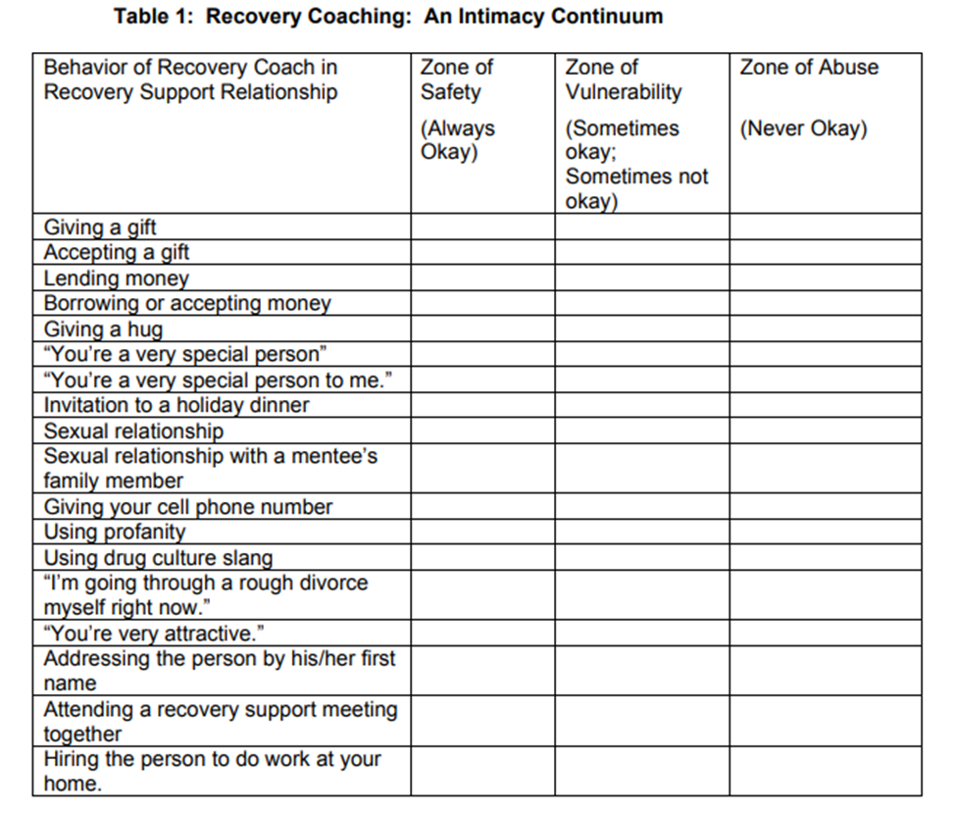

CRAFT-RECOVERY COACHING Handout 3b
Ethical Decision-Making Work Sheet

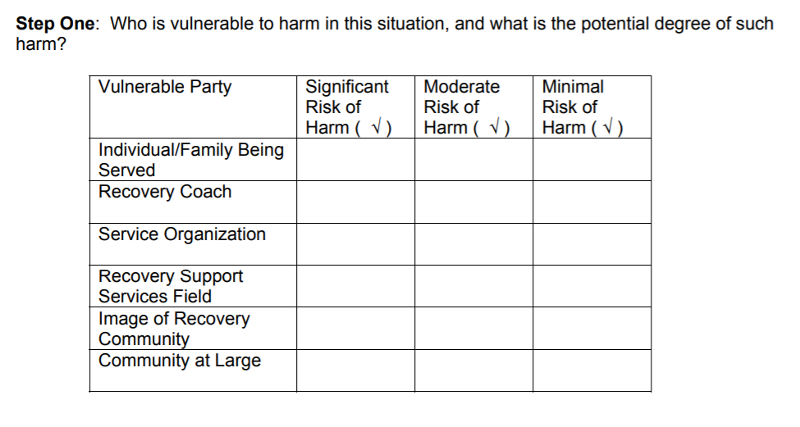
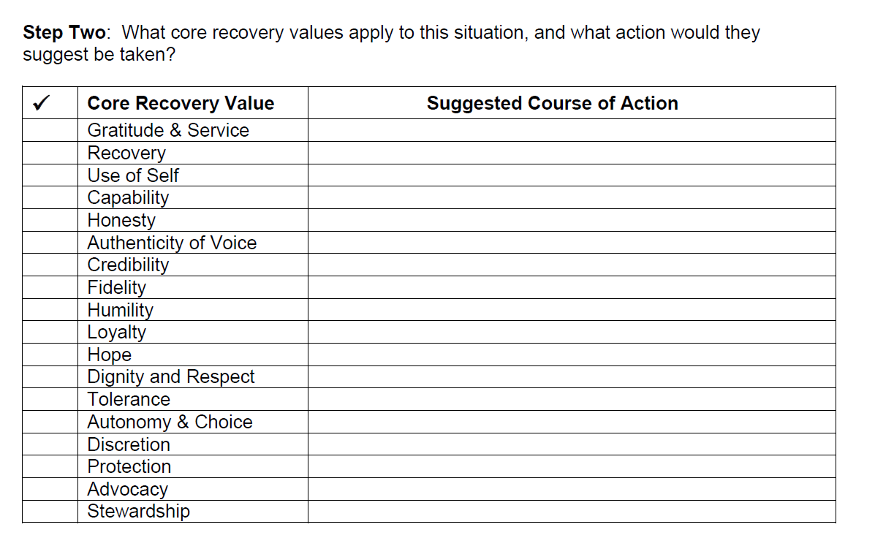

CRAFT-RECOVERY COACHING Handout 3b Page 2
Ethical Decision-Making Work Sheet

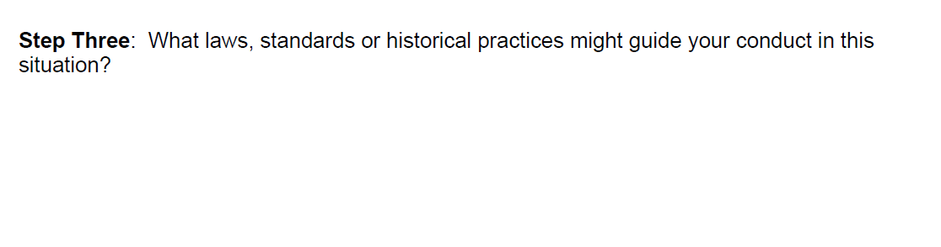
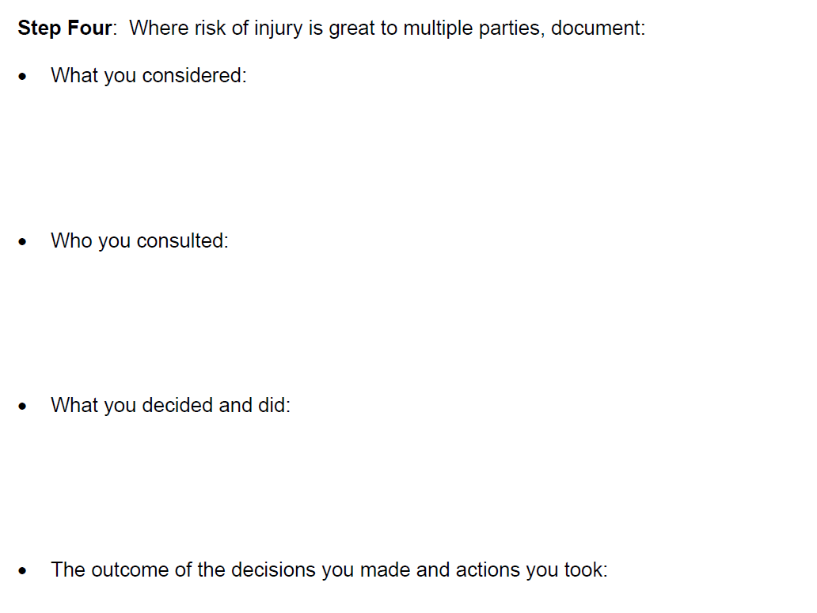

CRAFT-RECOVERY COACHING Handout 4a
Five Stages Of Change Interview

Helen Annis, Renate Schober and Elizabeth Kelly
Interview used to classify client into one of Five Stages of Change (1996)

- Precontemplation, 2. Contemplation 3. Preparation 4. Action 5. Maintenance Stage

1) Did you drink during the last 30 days? YES or NO

2) Are you considering quitting or reducing drinking in the next 30 days?

YES or NO

Code: Precontemplation Stage

Code: Contemplation Stage

3) Were you continuously abstinent during the past 30 days or did you reduce drinking in the past 30 days?

YES or NO

Code: Action Stage
Code: Precontemplation Stage

3a) Did you knowingly attempt at least once, to quit or reduce your drinking during the past 30 days?

YES or NO

Code: Preparation Stage
Code: Contemplation Stage

4) Were you continuously abstinent for more than 60 days or did you reduce drinking for more than the last 60 days?

YES or NO

Code: Entering the Maintenance Stage Code: Action Stage

Annis, Helen, Schober, Renate & Kelly, Elizabeth (1996)“Matching Addiction Outpatient Counseling to
Client Readiness for Change”, Experimental and Clinical Psychopharmacology, Vol. 4, No.1
Stephen Rollnick and Allison Bell, (1991) Brief Motivational Interviewing for Use by the Nonspecialist, a chapter from Motivational Interviewing, Preparing People to Change Addictive Behavior, William Miller & Stephen Rollnick eds, Guilford Press, NYC,NY,
Rollnick Stephen., & Miller, William .R. (1995). What is motivational interviewing? Behavioral and Cognitive Psychotherapy, 23,

Mid-Atlantic Addiction Technology Transfer Center mid-attc@mindspring.com , and at : http://www.mid-attc.org
and at : http://www.motivationalinterview.org/clinical/whatismi.html

Prochaska, James O., Norcross, John C. and DiClemente, Carlos, Changing for Good, William Morrow and Co. NY, 1994

Prochaska, J.O., DiClemente, C.C. & Norcross, J.C. “In Search of How People Change: Application to addictive behaviors”. American Psychologist, 1992,

CRAFT-RECOVERY COACHING Handout 4B
Stages of Change and the Corresponding Approaches

Stages of Change and Corresponding Approaches
Stage | Description | Approaches
Pre-  Contemplation | - Denies anything needs to  be changed  - Does not want any help  and doesn’t want to talk  about it  - May be defensive or  deflecting  - Is not aware of any  negative consequences | - Give information linking  client behavior and the  problems resulting from  the behavior  - Give factual information  - Provide education  - Show you are concerned  and are available
Contemplation | - May acknowledge  problem, but not  not ready to change  behavior  - Ambivalent about  changing  - Aware of some of the  pros and cons of  changing behavior  - Doubts long term benefits  outweigh the short  term costs  - Looks at all of the years  ahead without the  behavior | - Discuss the understanding  about ambivalence, it is  normal for everyone to  fear change  - Explore the ambivalence  - Focus on the clients in-  creased awareness of the  consequences  - Discuss the benefits of  changing  - Reinforce they are free to  choose  - Discuss responsibility for  changing  - One day at a time
Stages of Change and Corresponding Approaches
Stage | - Description | - Approaches
Preparation | - Getting ready to make a  change  - Researching options  - Gathering information  - Has decided to change  - Begins planning for a  change | - Exploring options  - Being allowed to choose  the best option for them  - Make a plan of action  - Help client identify avail-  able resources  - Provide assistance to over-  come barriers
Stages of Change and Corresponding Approaches
Stage | Description | Approaches
Action | - Actively involved in  taking steps to change  using a variety of  techniques  - Trying new behaviors  - Trying healthy risks  - New behaviors are not  yet stable  - Client develops WRAP  Plan | - Assistance in executing  WRAP plan  - Acknowledge feelings and  experiences are normal  - Identify and reduce triggers  - Develop coping skills  - Reward client when change  is successful  - Have the client reward  themselves
Maintenance | - Has established new  behaviors  - Maintains new behaviors  in the face of triggers and  conflict  - Can identify behaviors  that brings the client  close to relapse and  stops these behaviors,  before a slip  - Is opened to helping others | - Help with WRAP – Crisis  plan  - Reassurance of their WRAP  plan  - Working on back-up plans  - Evaluate their plan and  modify if necessary  - Affirmation of self-efficacy  - Supportive contact with  client  - Describe sponsorship and  service
Taken from: Melissa Killeen, Recovery Coaching-A Guide to Coaching People in Recovery from Addictions, Stages of Change and Corresponding Approaches, Appendix F, pgs. 219-220

CRAFT-RECOVERY COACHING Handout 4c
Writing the Recovery Plan

The person in recovery builds their personal recovery plan and reviews the plan with their coach and therapist. The coach and therapist can have some input, but they do not write the plan- the recoveree must write and OWN their recovery plan
A recovery plan lasts five years or more, it takes at least five years to achieve long term recovery
The plan can be modified but never dropped
What is your recovery goal?
________________________________________________________________________________________________________________________________________________________
Do you have a connection to a recovery community organization?
____________________________________________________________________________
Name the people in recovery you have contact with on a regular basis?
____________________________________________________________________________
Are you involved in a mutual support group (AA, NA, GA)? Name the group(s).
____________________________________________________________________________
Are you a member of a faith-based recovery support group? Name the group(s).
____________________________________________________________________________
How do you plan to spend social time with others in recovery?
____________________________________________________________________________
Do you want to learn more about recovery? How will you do this?

Do you have any conclusions about developing your recovery plan?
____________________________________________________________________________________________________________________________________________________________________________________________________________________________________

CRAFT-RECOVERY COACHING Handout 4c Page 2
Writing the Recovery Plan

What steps do you need to take to achieve your recovery goal?
____________________________________________________________________________
Who else may be involved?

When can I hope to see the goal achieved?
____________________________________________________________________________
What kind of literature can I read?
____________________________________________________________________________
What kind of retreats can I attend

Questions about your physical health

Do you need to see a doctor, therapist, psychiatrist, or dentist and why?
____________________________________________________________________________________________________________________________________________________________________________________________________________________________________
Do you have a healthcare provider?
___________________________________________________________________________
If you have been prescribed medication – do you take it regularly? Are you having trouble paying for it?
___________________________________________________________________________
How is your diet? Your weight?
___________________________________________________________________________
CRAFT-RECOVERY COACHING Handout 4c Page 3
Writing the Recovery Plan

Do you exercise?
__________________________________________________________________________
Do you have any conclusions about the state of your physical health?

What is your physical health and wellness goal?
__________________________________________________________________________
What steps do you need to take to see your physical health goals be achieved?
___________________________________________________________________________
Who else may be involved
___________________________________________________________________________
When do you want to achieve these goals?

What is your emotional health plan?
___________________________________________________________________________
Do you strive to be in a healthy relationship?
___________________________________________________________________________
Are you seeing a therapist? Do you want to see a therapist?
____________________________________________________________________________
Do your healthcare providers know you are in recovery (and do not prescribe addictive medicine)?

CRAFT-RECOVERY COACHING Handout 4c Page 4
Writing the Recovery Plan

If you have medication, do you take it as prescribed?
____________________________________________________________________________
What other questions regarding your health should you be asking?

What is your healthcare and wellness plan?
____________________________________________________________________________
What steps do you need to take to achieve your plan?
____________________________________________________________________________
Who else may be involved?
____________________________________________________________________________
When do you want to accomplish this goal?

Questions about your spiritual health

Do you need to learn more about a religion, a movement, or spirituality?
____________________________________________________________________________
Do you have a spiritual leader or advisor? What is his/her name?
___________________________________________________________________________
If you have embraced a spiritual direction- are you disciplined in your practice?
___________________________________________________________________________
Do you take time regularly for prayer, meditation, or personal reflection?
___________________________________________________________________________
Do you engage with others socially who share your spiritual commitment?
CRAFT-RECOVERY COACHING Handout 4c Page 5
Writing the Recovery Plan

Do you have any conclusions about the state of your spiritual health?

What is your spirituality plan?
___________________________________________________________________________
What steps do you need to take to achieve your plan?
___________________________________________________________________________
Who else may be involved?
___________________________________________________________________________
When do you want to accomplish this goal?

Questions about your living accommodations

Do you need to have more support for your recovery in your living environment?
____________________________________________________________________________
Are your living companions or partners, in recovery?
____________________________________________________________________________
Is your living situation safe?
____________________________________________________________________________
Do you have difficult financial situations that affect your living situation?
____________________________________________________________________________
Can you change your living situation?

CRAFT-RECOVERY COACHING Handout 4c Page 6
Writing the Recovery Plan

Do you have any conclusions about the state of your living accommodations?

What is your living accommodations plan?
___________________________________________________________________________
What steps do you need to take to achieve your plan?
____________________________________________________________________________
Who else may be involved?
____________________________________________________________________________
When do you want to accomplish this goal?

Questions about your education or job

Do you need a job?
____________________________________________________________________________
Does your job support your recovery goals?
___________________________________________________________________________
Are you satisfied with your educational status?
____________________________________________________________________________
Do you need additional training?
____________________________________________________________________________
Can you change your job situation?
CRAFT-RECOVERY COACHING Handout 4c Page 6
Writing the Recovery Plan
Do you have any conclusions about the state of your job or education?
_______________________________________________________________________________________________________________________________________________________________________________________________________________________________________________________________________________________________________________
What is your job or education plan?
____________________________________________________________________________
What steps do you need to take to achieve your plan?

Who else may be involved?
_____________________________________________________________________________
When do you want to accomplish this goal?

Questions about your daily living management

Do you wash and brush your teeth daily?
___________________________________________________________________________
Do you have an organized & clean house?
___________________________________________________________________________
Did you make you bed today?
Are your clothes washed every week?
___________________________________________________________________________
What kind of shape is your car in?
___________________________________________________________________________
Is your vehicle clean? Maintained? Insured?

CRAFT-RECOVERY COACHING Handout 4c Page 7
Writing the Recovery Plan

If you use mass transit for going to work, do you have a frequent rider discount card?

Do you have a checking account and a savings account?
____________________________________________________________________________
Can you access your financial records electronically?
____________________________________________________________________________
Do you have credit card debt or student loan debt?
____________________________________________________________________________
Do you have retirement plan at work - do you participate in it?
____________________________________________________________________________
Can you access your financial records electronically?
____________________________________________________________________________
Do you have a budget or a plan to manage your money?
____________________________________________________________________________
Do you have a family - if so - do you have life insurance and a will?
____________________________________________________________________________
Do you have any conclusions about the state of daily living management?
_______________________________________________________________________________________________________________________________________________________________________________________________________________________________________________________________________________________________________________
What is your living management plan?
____________________________________________________________________________
What steps do you need to take to achieve your plan?

CRAFT-RECOVERY COACHING Handout 4c Page 8
Writing the Recovery Plan

Who else may be involved?
_______________________________________________________________________
When do you want to accomplish this goal?
________________________________________________________________________________________________________________________________________________________________________________________________________________________________________________________________________________________________________________

What other areas to you wish to explore?
___________________________________________________________________________
What steps do you need to take to achieve your plan?
___________________________________________________________________________
Who else may be involved?
___________________________________________________________________________
When do you want to accomplish this goal?

Create a calendar- an old fashion 8” x 10” wall calendar. Plan the next four months and write your recovery plan goals into the calendar

CRAFT-RECOVERY COACHING Handout 4d
Writing the Relapse Prevention Plan
Include WRAP WORKBOOK in Handout

