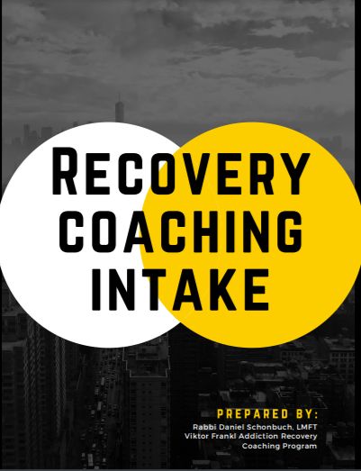

Progress Notes:

- What are their primary and secondary addictions?____________________
- Where are they on the Stages of Change?__________________________
- What are their main triggers?____________________________________
- What are their internal resources?________________________________
- What are their external resources?________________________________
- What are the key areas they are lacking in?_________________________
- What is their level of motivation?_________________________________
- What are their goals this week?_________________________________________________________________________________________________________________
- Other important points of session:________________________________________________________________________________________________________________

